**Write a mapreduce program to use CombineFileInputFormat. Pass a directory containing multiple small files. The program should be able to pick multiple files in a single mapper**

**Driver class:**

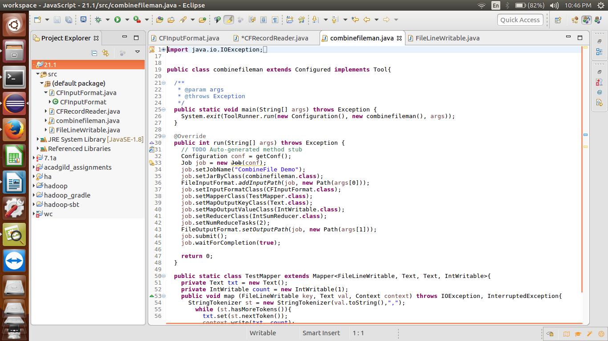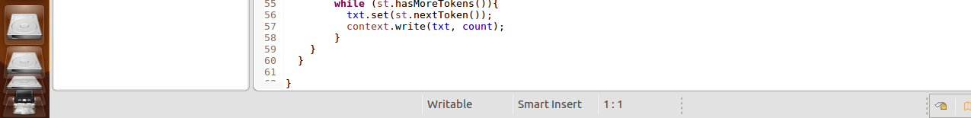

**Combine file input format class:**

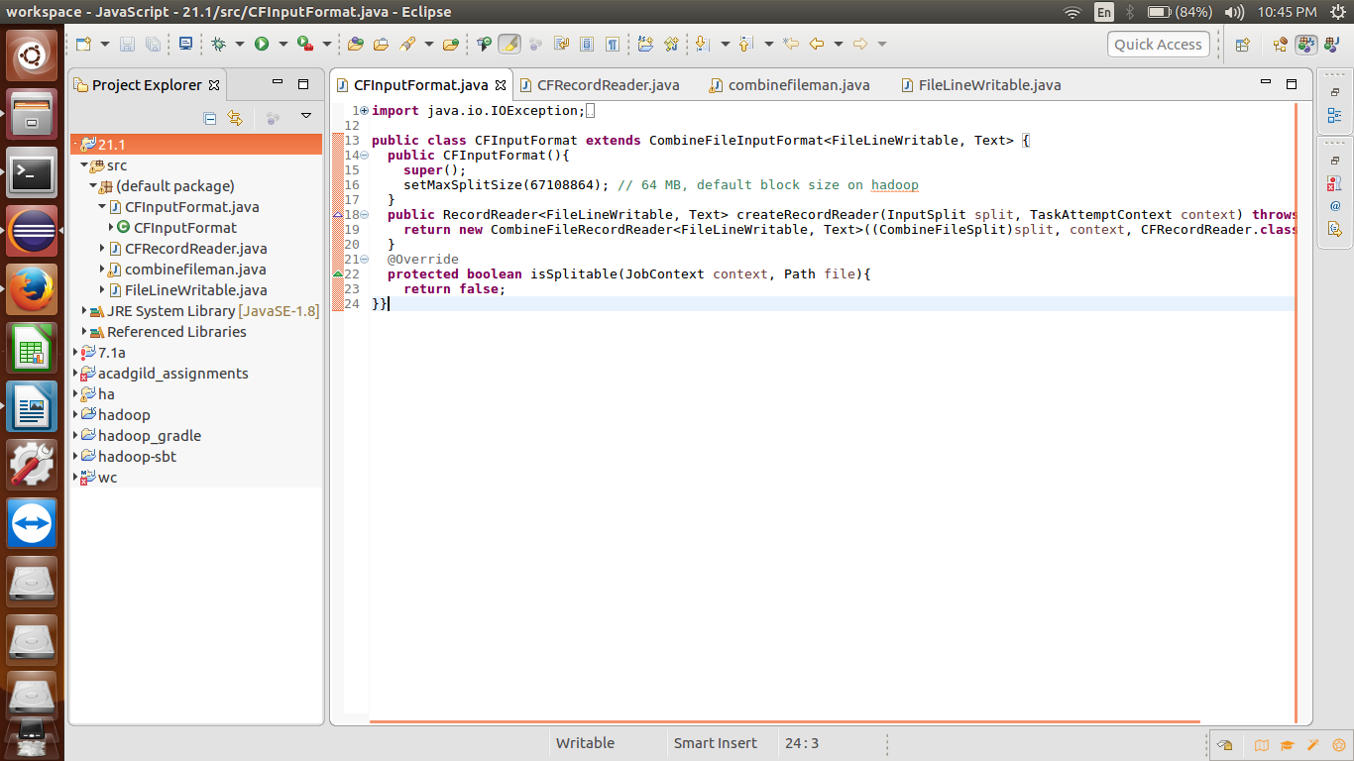

**Record reader class:**

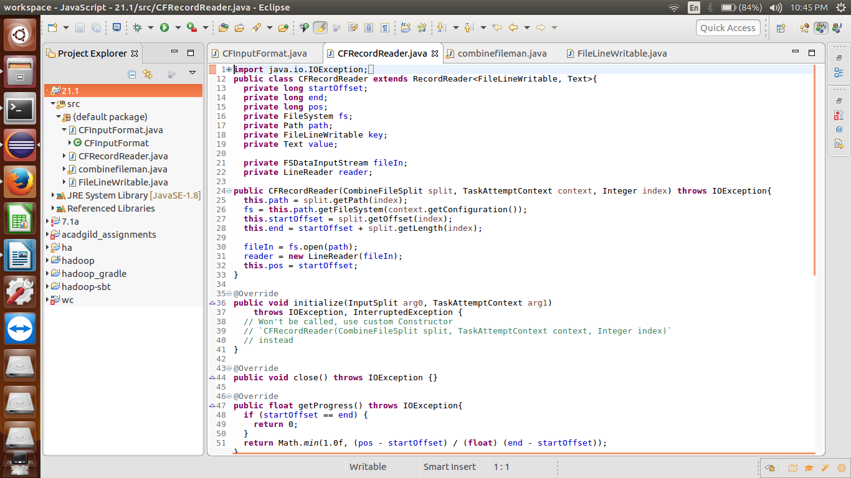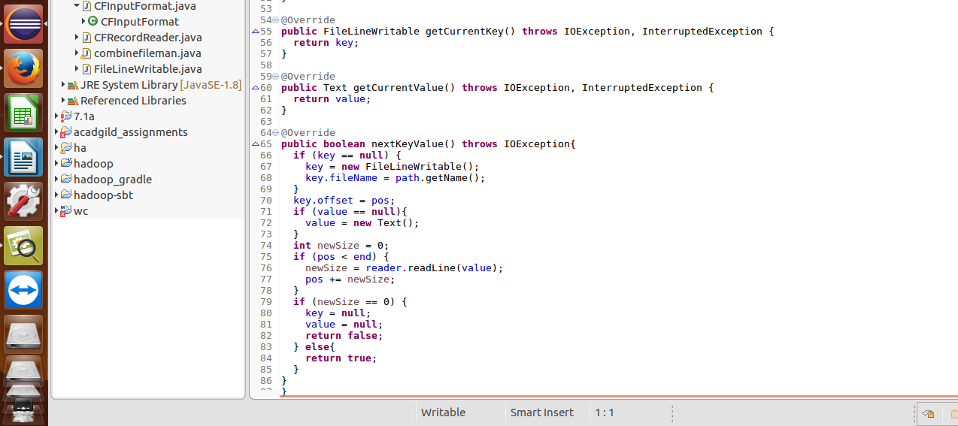

**Writable comparable class:**

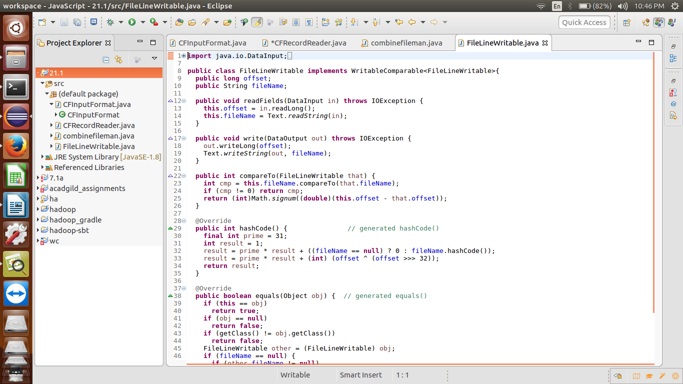

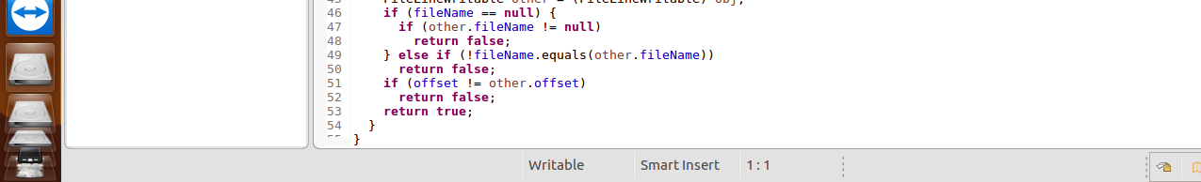

**Input files:**

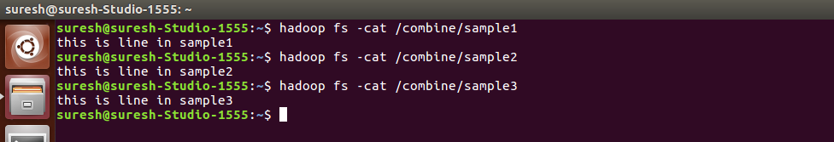

**Running jar:**

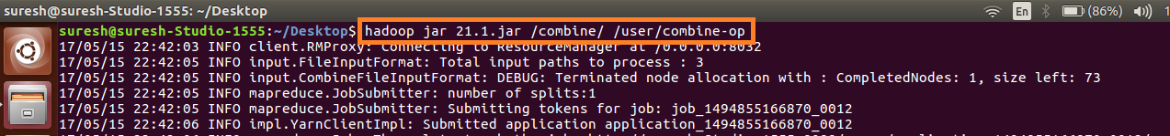

**Output:**

